**ITITIU19228 – TRẦN NGUYỄN THƯƠNG TRƯỜNG – REPORT LAB 2- COMPUTER ARCHITECTURE**

**Question 2.1:**

* The real MIPS instruction for the instruction “**li $t0, 5**”is: **ori $8, $0, 5**
* 

**Question 2.2:**

* The real MIPS instruction for the instruction “**li $t0, -5**” is: **lui $1, -1**
* 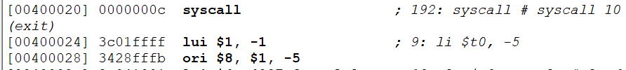
* **Explain:**

**Question 2.3:**

* The real MIPS instructions for “**li $t0, 0xaabbccdd**” is: **lui $1, -21829**
* 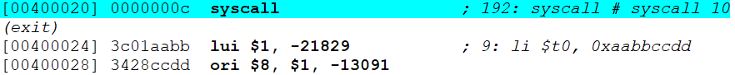
* **Explain**: **lui $1, -21829**

**ori $8, $1, -13091**

**-21829: aabb**

**-13091: ccdd**

**Question 3.1:**

* The **secret number is: 506**

T0= 0**x1fa -> 506**

bne $t0, $t1, LOSE

**Question 3.2:**

* MIPS code after fixed, i put in Lab2_3.2.s file. Check it help me, teacher !

**Question 3.3:**

* MIPS code after fixed, i put in Lab2_3.3.s file. I used **bgt** for this game to create if, else condition. Check it help me, teacher !

**Question 3.4:**

* MIPS code after fixed, i put in Lab2_3.4.s & Sample picture Lab2_3.4.png. I used **j loop** for this game to player can keep guessing until he find the secret number. Check it help me, teacher !

**II. MSP430**

**Step 1:**

**Step 2:** Not run, the values of these registers (PORT_1_2):

* P1OUT: 0xB9
* P1IN: 0x06
* P1DIR: 0x00
* P1REN: 0x00
* P1IFG: 0x00

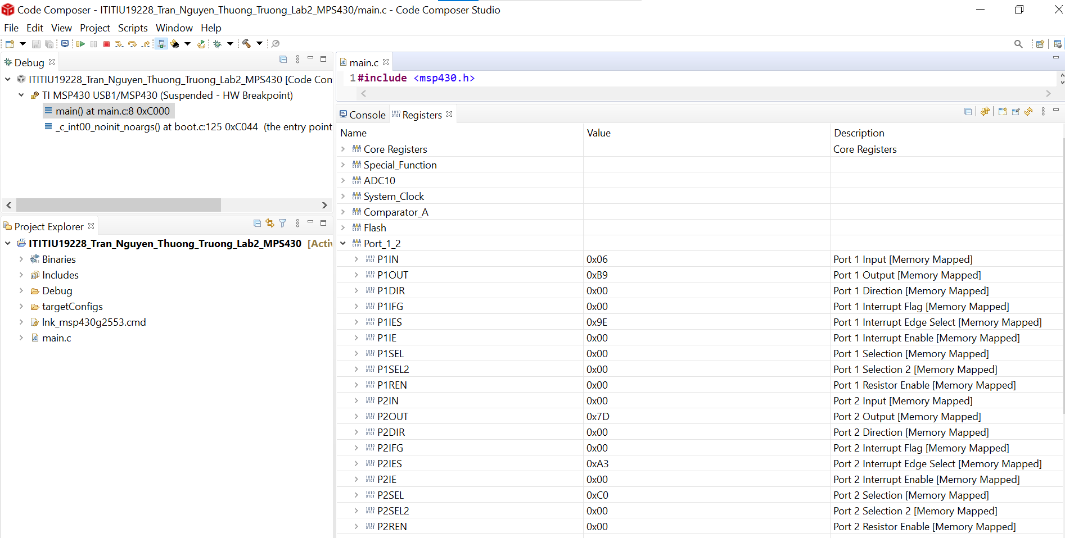

**Step 3:** Run, observe and collect the values of these registers in case of

|  |  |  |
| --- | --- | --- |
|  | **Red LED On** | **Green LED On** |
| P1OUT |  |  |
| P1IN |  |  |
| P1DIR |  |  |
| P1REN |  |  |
| P1IFG |  |  |

**Step 4:**

* This is MIPS code
* 